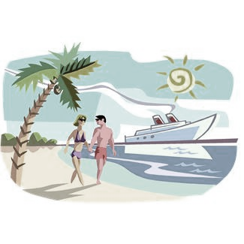
Western Caribbean Polka Cruise
December 6 - 13 2026
Aboard Norwegian Cruise Line's Cruise Ship the – EPIC
John Gora - Ed Forman (EFO) – Robbie Piatkowski (Gorale) Jack Beachly (Chi Push) - Bob Frydryk (EFO) Jeff Yash (Blue Magic)
Rich Zebrowski (Chi Push) - John Cieplik (EFO) + more TBA

Fly to Orlando, Florida for a 7 Night Cruise – Port Canaveral, FL
JAMACA - BAHAMAS – COZUMEL - GRAND CAYMAN
*WELCOME ABOARD PARTY *24-HOURS OF NON-STOP FOOD * FULL CASINO *LARGEST NAUTICA SPA
*CAPTAINS COCKTAIL & GALA DINNER PARTY * ONBOARD DUTY-FREE SHOPPING *LATE NIGHT BUFFETS
*WIDE RANGE OF ENTERTAINMENT *STAGE SHOWS *POLKA PARTIES *INTERNET CAFÉ
*SEASIDE THEATRE *HALF MILE OUTDOOR WALKING AREA * WHIRLPOOLS
PER PERSON CRUISE ONLY – INCLUDES ALL TAXES in US $
Inside -$849.00 Outside – not available Balcony -$1250.00
More at Sea Package on Balcony cabin – includes beverage package, Specialty dining (3 meals)) WI FI, $50.00 onboard credit - $1499.00pp
Inside cabins – Beverage package, $50 onboard credit -$1099.00
3rd & 4th Rates – rates when booked Single rate cabin

Extra Night before/after cruise in Orlando – Embassy Suites ($tba)per night (includes 13% tax) 2hr open bar/full breakfast

One Way Transfers Day After the Cruise to Orlando Airport – $39.50 pp

Cheers Liquor Package – If purchasing Cheers Package, both in cabin must buy/ not just one!

If you use NCLto book your airfare – Their price includes round trip transfers to/from airport/ship and all air taxes. If you book your own airfare, you can still buy transfers [above prices] or you can get to the ship on your own, you will be responsible!

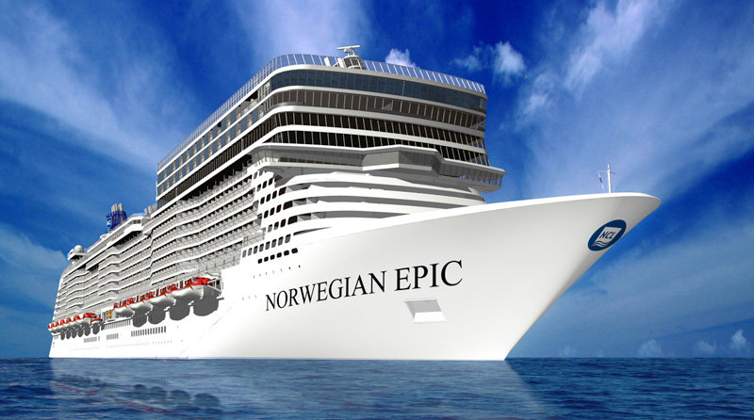
Seven Night Southern Caribbean Itinerary
Day Port Arrive Depart
Sun Port Canaveral 4:00pm
Mon Great Stirrup Cay 8:00am 5:00pm
Tues at Sea
Wed Falmouth 7:00am 5:00pm
Thur Georgetown 7:00am 4:00pm
Fri Cozumel 10:00am 7:00pm
Sat at sea
Sun Port Canaveral 7:00 am

Massbrass2002@yahoo com

RESERVATION FORM
Please complete the reservation form to confirm your spot for the 2026 NCL “EPIC” Polka Cruise

1) Last Name: ______________________________ 1) First Name: ___________________________________

2) Last Name: ______________________________ 2) First Name: ___________________________________

Address: ___________________________________________________________________________________

City: ______________________________________ State: _____________________ Zip:_______________

Home PH: ______________________ Cell #: ___________________ email:________________________________

Birth Date: #1)______________________________ Birth Date #2)____________________________________

Cabin Choice: Inside   Balcony   People in Cabin: 1  2  3  4 

Extra Names in Cabin: (3) ________________________________ (4) _______________________________________

Airfare: Book My Own   NCL Cruises Air   Check Air Rates for Me  Air City: ___________________

R/T Transfers: NCL Orlando - $39.75pp  - R/T $79.50pp   Polka Bus Day Early – price /tba   

Insurance: 10% of fare Yes  No    US Citizen: Yes  No  Country: ________

Extra Night: Embassy Suites at Orlando, FL Price -$259.00 Pre Yes  No   Post Yes  No      

Dining: Will be decided on playing times for group Pre-paid Gratuities - $140.00 pp Yes  No 

More at Sea Package - Yes  No  Soda Package – (If not taking the beverage Pkg)($105.00pp): Yes  No 

Cruise Tee Shirt Size (S, M, L, XL, 2XL, 3XL): Cruisers: ( 1 ) _____ ( 2 ) _____ ( 3 ) _____ ( 4 ) _____

Special Requests: __________________________________________________________________________

Deposit: Check: Yes  No  Check Number: #_____________ Amount: $ ______________________

Credit Card Type: ____________ Credit Card #________________________________ Exp. Date: _______

CVC 3/4 digit code: ________ Signature: _______________________________________

NOTE: NO BUY-IN’S! You must book your Polka Cruise with one of the hosts, bands or musicians to be part of our group.

Deposit Due By: June 6, 2026 - $350.00 p/p with application - Final Payment Due: August 1, 2026
Checks payable to: Bob Wojtowicz

Cell: 413-883-8734 Email: Massbrass2002@yahoo.com

Mailing address:114 Rocky Hill Rd Hadley, Ma 01035

TERMS AND CONDITIONS:
DEPOSIT: A $350.00 per person deposit due upon booking. Reservations will not be confirmed without a deposit.
FINAL PAYMENT: Due no later than August 1, 2026 to assure your trip. Payments made after this date may be assessed a late fee from NCL. All payments must be made by check or credit card to Bob Wojtowicz
CANCELLATIONS AND REFUNDS: A $25.00 per person cancellation charge will be assessed from your payment if you cancel at any time, with or without insurance from Bob Wojtowicz. Cancellations from NCL up to (76 days- none) (75-46 days –deposit) (45-15 days-50%of the total fare) (14 days or less – no refund) must be cancelled with a registered letter to Bob Wojtowicz by October 16, 2026 or you will receive no refund.
TRIP INSURANCE: Is strongly recommended!
TRIP CHANGES: NCL charges $50.00 per change in your reservation. (Ex: name change, misspelling) AFTER FINAL PAYMENT DATE !
HEAD LINERS & BANDS: At any time, a headliner or band may cancel or bring a limited number of musicians due to the number of Polka travelers in the group. We have no control of who cancels and we are not responsible for those who do.
DOCUMENTATION: All US/Canadian travelers need a valid passport.

