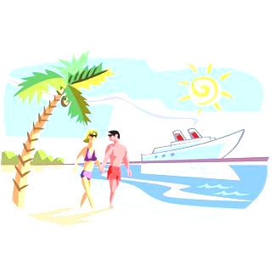
Western Caribbean Polka Cruise
November 3-9, 2024
Aboard Carnival Cruise Line's New Cruise Ship the – HORIZON
POLKA ALL–STARS 
HOST MC – Frank Liszka (the Boys / TBC)
Eddie Forman (EFO) - John Cieplik (EFO) – Ed Blazonczyk Jr. (Versatones)
John Gora (Gorale) – Bob Frydryk (EFO) – Rich Zebrowski (Chicago Push)
Polka Show Host – John Baras (Midwest Polka Show)

Fly to Fort Lauderdale or Miami, Florida for a 6 Night Cruise – Miami Port
Jamaica – Cozumel – Grand Cayman
*WELCOME ABOARD PARTY *24-HOURS OF NON-STOP FOOD * FULL CASINO *LARGEST NAUTICA SPA
*CAPTAINS COCKTAIL & GALA DINNER PARTY * ONBOARD DUTY-FREE SHOPPING *LATE NIGHT BUFFETS
*WIDE RANGE OF ENTERTAINMENT *STAGE SHOWS *POLKA PARTIES *INTERNET CAFÉ
*SEASIDE THEATRE *HALF MILE OUTDOOR WALKING AREA * WHIRLPOOLS
PRICE PER PERSON CRUISE ONLY – INCLUDES ALL TAXES

Inside -$749.00 Outside -$849.00 Balcony -$1049.00
3rd & 4thRates – rates when booked
OPTIONAL CHEERS LIQUOR PACKAGE - $424.45pp
Insurance from Carnival - $65.00pp (inside) $79.00pp (outside) $95.00pp (balcony) Optional Payment Plans Available
Extra Night before/after cruise in Miami – Embassy Suites ($247.47)per night (includes 13% tax) 2hr open bar/full breakfast
One Way Transfers Day of cruise from CCL – Fort Lauderdale Airport R/T / $73.98pp Miami Airport R/T / $45.98pp
Cheers Liquor Package – If purchasing Cheers Package, both in cabin must buy/ not just one!
Air Prices: All Air-Cities available on Request! We will check what is offered from Carnival Cruise Lines or Bob Wojtowicz will check for air prices or you can book your own! If you use Carnival to book your airfare – Their price includes round trip transfers to/from airport/ship and all air taxes. If you book your own airfare, you can still buy transfers [above prices] or you can get to the ship on your own, you will be responsible!
Six Day Western Caribbean Itinerary
Day Port Arrive Depart
Sun Miami 4:00pm
Mon Fun Day at Sea
Tues Ocho Rios, Jamaica 9:00am 5:00pm
Wed Grand Cayman 8:00am 4:00pm
Thur Cozumel, Mexico 10:30am 6:30pm
Fri Fun Day at Sea
Sat Miami Port 8:00am
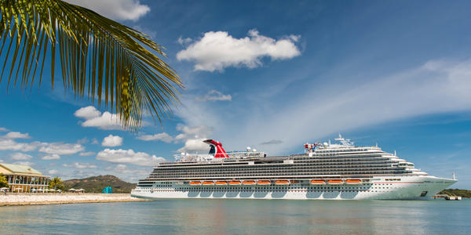

Carnival Horizon
For more information visit:
www.bobspolkatrips.com

COMPLETE FORM TO CONFIRM YOUR RESERVATION FOR THE POLKA CRUISE

1) Last Name: ______________________________ 1) First Name: ___________________________________
2) Last Name: ______________________________ 2) First Name: ___________________________________
Address: ___________________________________________________________________________________
City: ______________________________________ State: _____________________ Zip:_______________
Home PH: ______________________ Cell #: ___________________ email:________________________________
Birth Date: #1)______________________________ Birth Date #2)____________________________________
Cabin Choice: Inside   Outside  Balcony   People in Cabin: 1  2  3  4 
Extra Names in Cabin: (3) ________________________________ (4) _______________________________________
Airfare: Book My Own   CCL Cruises Air   Check Air Rates for Me  Air City: ___________________
R/T Transfers: CCL Miami - $45.98pp q FLL - $73.98pp q  Your own way q
(Group from Embassy to ship - $10.00pp  After Cruise Miami Airport - $22.99pp q FLL - $36.99pp q )
Payment Plan: Yes  No  Insurance: Yes  No  US Citizen: Yes  No  Country: ________
Extra Night: Embassy Suites at Miami Airport : Pre Yes  No   Post Yes  No      
Dining: (Early Dining ) (Polka dances after early dining) Pre-paid Gratuities - $96.00 pp Yes q No q
Cheers Liquor Package - ($424.45pp) Yes q No q Soda Package - ($67.26pp): Yes  No 
Cruise Tee Shirt Size (S, M, L, XL, 2XL): Cruisers: ( 1 ) _____ ( 2 ) _____ ( 3 ) _____ ( 4 ) _____
Special Requests: __________________________________________________________________________

Deposit: Check: Yes  No  Check Number: #_____________ Amount: $ ______________________
Credit Card: ____________ Credit Card #_________________________________ Exp. Date: __________
If staying at the Embassy Suites, I will need a credit card to hold your room!
CVC 3/4 digit code: ________ Signature: _______________________________________

NOTE: NO BUY-IN’S! You must book your Polka Cruise with one of the hosts, bands or musicians or you will not be admitted in to any of the Polka functions! All functions are private on the ship!
Deposit Due By: July 6, 2024 - $350.00 pp with application - Final Payment Due: August 5, 2024
Your Vacation Contact:

Bob Wojtowicz
114 Rocky Hill Road, Hadley, MA 01035
Phone: (413)549-3941 or cell (413)883-8734 Email: massbrass2002@yahoo.com

MAKE CHECKS PAYABLE TO: BOB WOJTOWICZ
For more information on CCL – Carnival Horizon
visit our web-site: www.bobspolkatrips.com
__________________________________________________________________________________________________________________________
TERMS AND CONDITIONS:
DEPOSIT: A $350.00 per person deposit due upon booking. Reservations will not be confirmed without a deposit.
FINAL PAYMENT: Due no later than August 5, 2024 to assure your trip. Payments made after this date may be assessed a late fee from CCL. All payments must be made by check or credit card to Bob Wojtowicz.
CANCELLATIONS AND REFUNDS: A $25.00 per person cancellation charge will be assessed from your payment if you cancel at any time, with or without insurance from Bob Wojtowicz. Cancellations from CCL up to (76 days- none) (75-46 days –deposit) (45-15 days-50%of the total fare) (14 days or less – no refund) must be cancelled with a registered letter to Bob Wojtowicz by October 16, 2024 or you will receive no refund.
TRIP INSURANCE: Is strongly recommended!
TRIP CHANGES: CCL charges $50.00 per change in your reservation. (Ex: name change, misspelling) AFTER FINAL PAYMENT DATE !
HEAD LINERS & BANDS: At any time, a headliner or band may cancel or bring a limited number of musicians due to the number of Polka travelers in the group. Bob Wojtowicz has no control of who cancels and is not responsible for those who do. Bob Wojtowicz is only the travel agent booking your trip.
DOCUMENTATION: All US/Canadian travelers need a valid passport.

